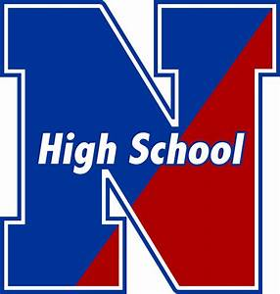

NESHAMINY HIGH SCHOOL

Athletic Department

**Directions:**

**Part 1- Concussion Education for Neshaminy High School Athletics**

1. Click on link: <https://forms.gle/3Sc8oARRNaFzpD3B8> to open the on-line learning module for Concussion Education.
2. Enter your email and then click on go to the next section.
3. Enter your first and last name, grade and select the sport you will be playing in the Fall.
4. The next section in the Pre-Test. It is 10 questions. Complete the Pre-Test and then go to the next section.
5. The next section is the presentation. It contains 3 modules. After each module you will have to answer a few questions. There are a total of 10 questions.
6. Once you have completed all 3 modules and answered the questions you will have completed Part 1 of your required Concussion Education.
7. Justin Lewis (Neshaminy Athletic Trainer) will be able to see who has completed the training and the score you received. If you have any questions please contact Justin (jlewis@neshaminy.org).
8. Now you will need to complete Part 2 of your Education – Baseline/Impact Test. – See other directions from your coach.